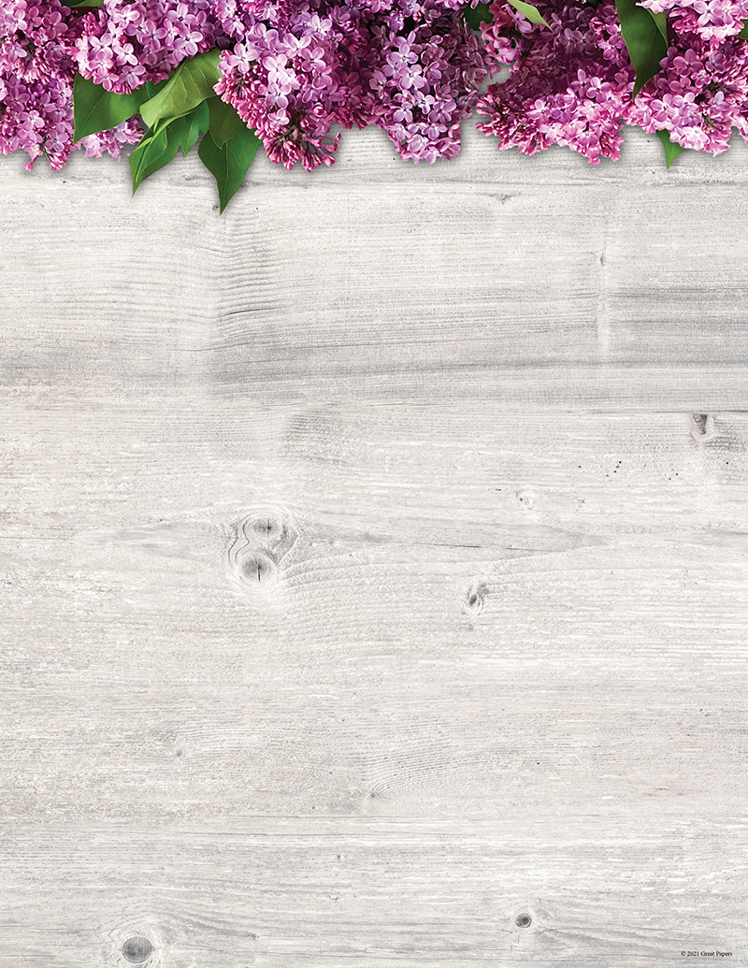

***Printing Tip:***

*For best results it is always a good idea to do a test print on a blank sheet*

*before using the actual product*